Greece/Ancient Greece Choosing Grid: Week 5
Our whole-school theme for this half-term will focus on learning about Greece/Ancient Greece. Each week you will be given a set of activities based on this theme to choose from. You may do these in any order that you wish. Some tasks will take longer than others, so feel free to complete these over several days if needs be.
Task: Atlantis - Fact or Fiction?  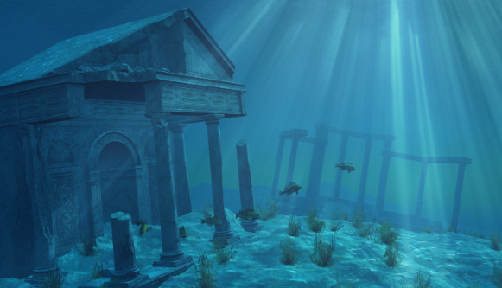  Some historians think that Atlantis was a great city that was lost to the sea. Others believe it to be an ancient Greek fairy tale.  What do you think?  What can you find out about Atlantis?  Is there any evidence that it actually existed? | Ancient Olympic Games  Originally, the games were part of a religious festival to honour Zeus. He was the god of the sky and the leader of the Greek gods who lived on Mount Olympus, the highest mountain in Greece. The winners were given olive wreaths to wear on their heads instead of medals.  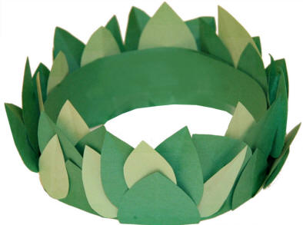  Can you make your own olive wreath out of green paper or leaves? | What were Greek Myths?  Task: Carry out some research about Medusa.  The links will help you with this. https://study.com/academy/lesson/medusa-lesson-for-kids-story-facts.html  Can you create a fact file based on what you have found out about this Greek myth?  Can you create Medusa? This could be by drawing a picture or modelling using play dough or paper mache?
What did the Ancient Greeks believe?  The ancient Greeks believed in many different gods and goddesses.  Each week you will be asked to carry out some research about one of them.  Goddess of the Week: Aphrodite  Task: Create a fact file based on what you have found out about this well-known goddess. | What is the history behind the Olympic rings?  Who designed the Olympic rings?  Why are there five rings?  What do each of the colours represent?  Why not have a go at making some? | Useful Websites  https://www.researchify.co.uk/  https://www.historyforkids.net/ancient-greece.html/  https://greece.mrdonn.org/  http://www.primaryhomeworkhelp.co.uk/Greece.html  https://www.ducksters.com/history/ancient_greece.php  https://www.bbc.co.uk/bitesize/topics/zkd9bdm  https://www.natgeokids.com/uk/discover/history/greece/10-facts-about-the-ancient-greeks/  https://www.dkfindout.com/uk/history/ancient-greece/

