Greece/Ancient Greece Choosing Grid: Week 2
Our whole-school theme for this half-term will focus on learning about Greece/Ancient Greece. Each week you will be given a set of activities based on this theme to choose from. You may do these in any order that you wish. Some tasks will take longer than others, so feel free to complete these over several days if needs be.
Why is the Parthenon so important?  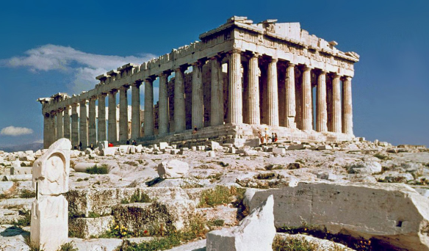  Task: Carry out some research of your own about the Parthenon.  Present your findings in a written format of your choice, or have a go at either drawing the temple or even making it (time to get out the Lego bricks again)! | When was the first marathon?  Do you know what a marathon is? Have you ever wondered where this word comes from?  The battle of Marathon is one of the earliest recorded battles in history.  Task: Watch the cartoon version of the story.  https://learnenglishkids.britishcouncil.org/short-stories/the-first-marathon  Do some research of your own about this historic event.  Find out about some famous marathon runners from modern times. | Why were shields important in Ancient Greece?  The Greek shield of Ancient Greece was called a hoplon or aspis. Hoplite, meaning Greek soldier, comes from this word. Generally, each hoplite choose their own shield design.  Task: Research Ancient Greek shields and have a go at designing and making your own.
What did the Ancient Greeks believe?  The ancient Greeks believed in many different gods and goddesses.  Each week you will be asked to carry out some research about one of them.  Goddess of the Week: Athena  Task: Create a fact file based on what you have found out about this important goddess. | Were the Ancient Greeks able to write?  The Ancient Greeks developed an alphabet for writing which was made up of 24 letters.  The Greek alphabet is still used today.  Interesting Fact: The word "alphabet" comes from the first two letters of the Greek alphabet: "alpha" and "beta".  Task: Practise saying the Greek alphabet (click on link below).  https://www.ducksters.com/history/ancient_greece/greek_alphabet.php  Have a go at writing some of the letters. | Useful Websites  https://www.researchify.co.uk/  https://www.historyforkids.net/ancient-greece.html/  https://greece.mrdonn.org/  http://www.primaryhomeworkhelp.co.uk/Greece.html  https://www.ducksters.com/history/ancient_greece.php  https://www.bbc.co.uk/bitesize/topics/zkd9bdm  https://www.natgeokids.com/uk/discover/history/greece/10-facts-about-the-ancient-greeks/  https://www.dkfindout.com/uk/history/ancient-greece/

