Year 5 Newsletter

Welcome to the start of a new academic year! I am really looking forward to getting back to learning – it’s lovely to see everyone back!

Is there anybody out there?
This half term we will be learning about our first science topic, The Earth and Space. We will investigate our solar system, important days in history related to space exploration, the Earth and Moon and discuss whether we are alone in the universe…

English

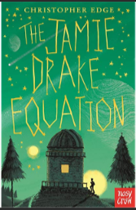
Linking with our theme, this half terms focus book will be ‘The Jamie Drake Equation’ by Christopher Edge, an exciting tale of primary school life, aliens and space exploration. Over the half term, building on our reading work, we will create a report about a newly discovered alien, followed by a recount of a space mission,
During grammar lessons we will be focussing on punctuation, paragraphs, tenses and relative clauses. In addition to this, we will have daily handwriting and spelling lessons where we aim to develop children’s understanding and add to their prior knowledge.

Mathematics
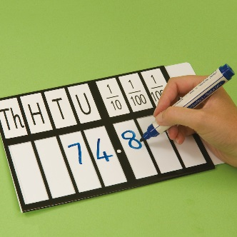
We will begin this term by applying our understanding of number and place value, before moving onto consolidating our understanding of measures, geometry and fractions, decimals and percentages. It is vital that all children are secure in their knowledge of number facts. We therefore strongly encourage children to continue to practise their times tables at home.

PE
This year, Year 5 will be receiving PE lessons on Wednesday and Thursday. We are very lucky to have a PE coach at Birklands, who will be teaching the children a range of skills. In order to take part, children need to be wearing their PE kit, which includes a white t shirt, black shorts and trainers. Please ensure that children arrive to school wearing their kit.

Homework
It is expected that children read at home at least three times each week. Reading is such an essential skill, particularly in Upper Key Stage 2. The more your child reads, the better their reading, comprehension, spelling and writing will become. Whenever your child reads at home, please sign their reading diary. These reading diaries need to be brought to school each day. Maths, English or topic homework is set each Thursday and due in on Tuesday. Homework will always link to the work in class that week, therefore, it is essential that your child brings their homework in on time so that they are prepared for their new learning.

It is vital that children attend school every day. Please ensure that your child is punctual to ensure they do not miss any learning.

If you have any questions please do not hesitate to come and see us or give us a phone call!

Thank you for your continued support,

Mr. Marsh

