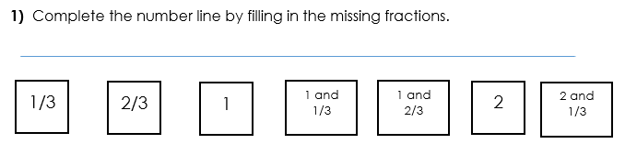
Tuesday 30.06.2020
- 1, 1 ½, 2, 2 ½, 3, 3 ½, 4, 4 ½, 5

- Abbie is correct because the number line is increasing by one eighth each time, so after 17/8 comes 18/8. Hannah is also correct because 18/8 written as a mixed number would be 2 2/8. (18 divided by 8 is 2 with two left over). Jon is incorrect – he has worked out that the answer is 18/8 but has not converted this to a mixed number correctly.

- The statement is true. You should have drawn a number line with both improper fractions and mixed numbers to show how they are related to each other.

