Thursday 21.05.2020
Fluent in Five
- $\frac{7}{18}$+ $\frac{4}{18}$=
- 180 ÷ 10 =
- 817 – 109 =
- 7 x 12 =
- 56 ÷ __ = 7

Times Table Rockstars
Spend 10 minutes on TT Rockstars (ON SOUNDCHECK PLEASE!)
Maths Task
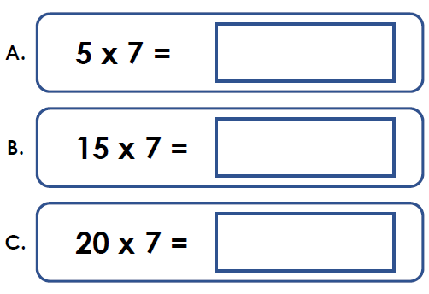
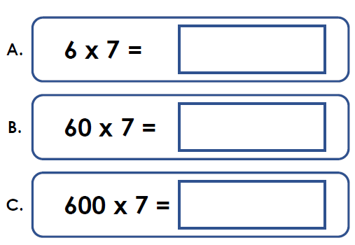
Today you will continue with your 7 times table work, looking at the multiplication and division facts.
1)

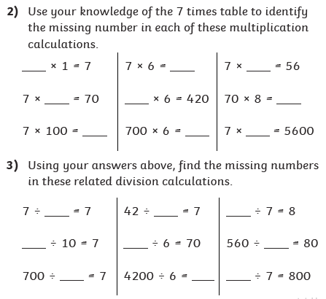
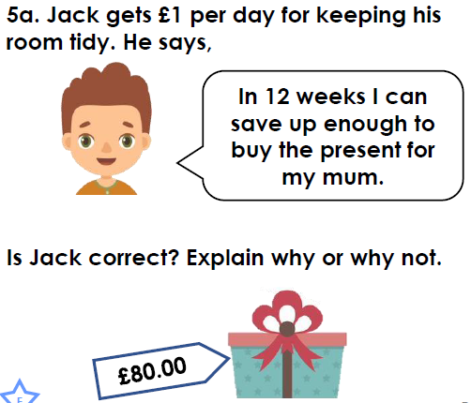
4)

