Friday 19.06.2020
Arithmetic

- 3,710 + 100 =
- 2,734 + 179 =
- 7,021 – 2,897 =
- 5 x 3 x 4 =
- 1.9 + 2.7 =

- 350 ÷ 5 =
- $\frac{4}{6}$ of 72 =
- 100 x ___ = 36
- 12 x 7 =
- 8 x 8 =
Times Table Rockstars
Spend 10 minutes on TT Rockstars (ON SOUNDCHECK PLEASE!)
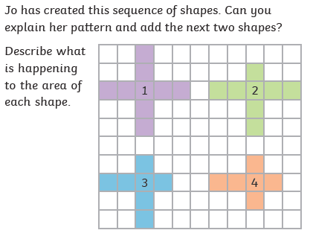
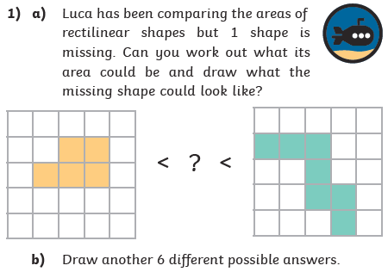
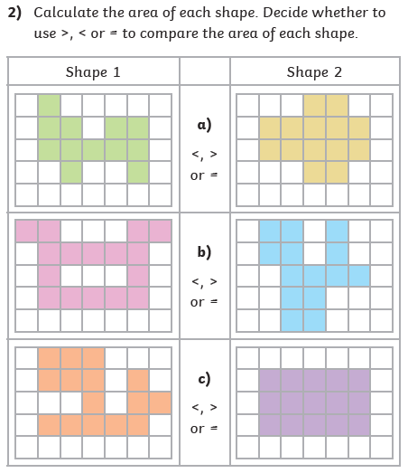
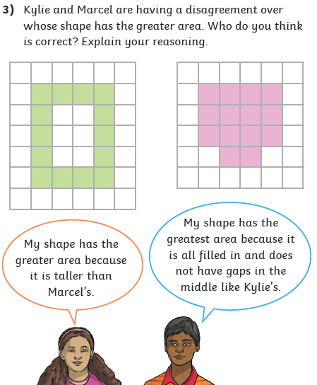
Maths Task – Comparing Area
1)
2)
3)
4)

