Wednesday 13.05.2020
Fluent in Five
- 823 + 1,991 =
- 642 – 287 =
- 48 x 6 =
- 29 x 9 =
- 84 ÷ 3 =
Times Table Rockstars
Spend 10 minutes on TT Rockstars (ON SOUNDCHECK PLEASE!)
Maths Task
Today we will be recapping dividing by 1. Dividing a number by 1 means sharing it between just one group. For example, if I have 12 apples and I share them between 1 friend, the friend will get 12 apples.
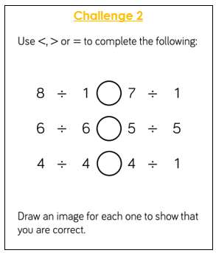
12 ÷ 1 = 12
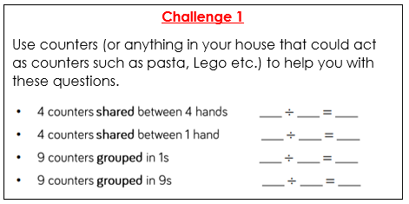
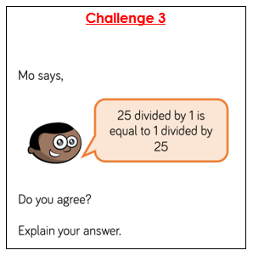
Challenge 4
