Tuesday 09.06.2020
Fluent in Five
- 2 x 7 x 9 =
- 1,037 + 94 =
- CCCXXVIII =
- 49 ÷ 7 =
- 100 x 45 =
Times Table Rockstars
Spend 10 minutes on TT Rockstars (ON SOUNDCHECK PLEASE!)
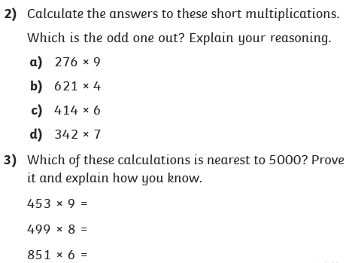
Maths Task – Multiplying 3-digit numbers by 1-digit numbers
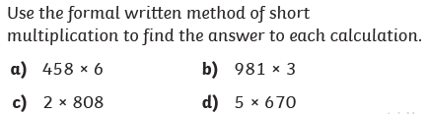
1)

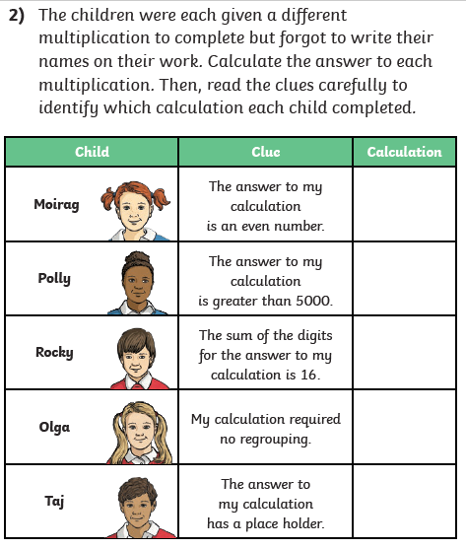
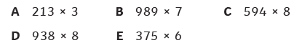
4)

