Wednesday 03.06.2020
Fluent in Five
- 7 x 8 x 2 =
- 10 x 14 =
- 100 x 16 =
- 207 + 29 =
- 2,013 – 974 =
Times Table Rockstars
Spend 10 minutes on TT Rockstars (ON SOUNDCHECK PLEASE!)
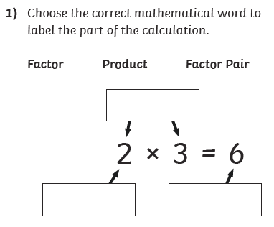
Maths Task - Factor Pairs
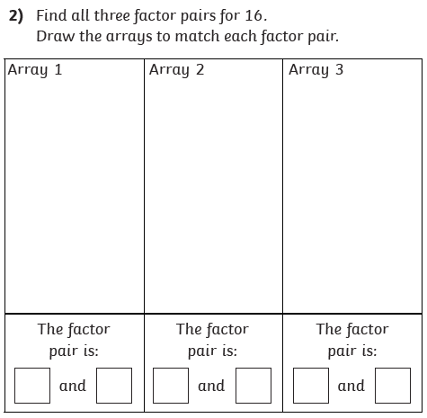
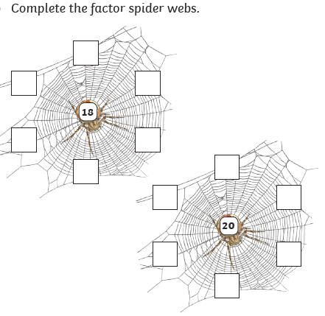
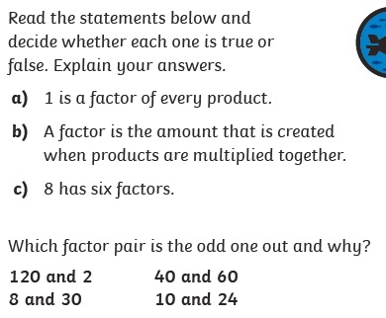
3)
4)
5)

