Tuesday 02.06.2020
Fluent in Five
- 804 + 1,207=
- Write 152 in Roman Numerals
- 121 ÷ 11 =
- 18 x 10 =
- 2,700 ÷ 10 =
Times Table Rockstars
Spend 10 minutes on TT Rockstars (ON SOUNDCHECK PLEASE!)
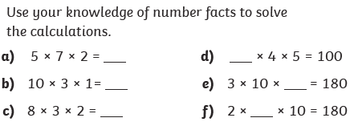
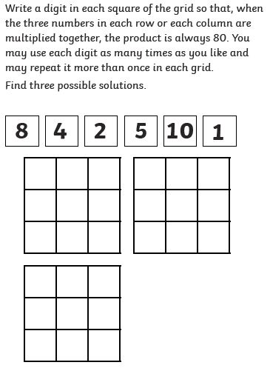
Maths Task - Multiply 3 numbers
1)
4)
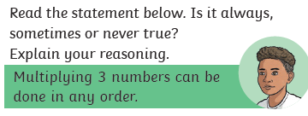
2)

