Birklands Primary School – SCIENCE Knowledge Organiser | Year: 3  Topic: Animals Including Humans

Previous learning - What I should already know:  - Know that animals have offspring that grow into adults and name common offspring  - Know that animals need water, oxygen and food for survival including humans  - Know and explain why exercise and the right types of food is important for humans  - Understand the importance of hygiene to keep humans healthy. | Skeletons;  -protect organs inside the body  -allow movement  -support the body and stop it falling to the floor  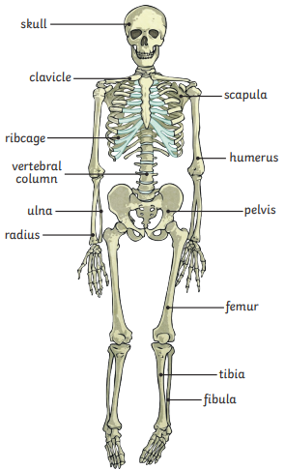 | Key Vocabulary  nutrition food needed to live and stay healthy.  skeleton a framework made of bone that supports and protects the body  muscle soft tissues in the body that contract and relax to cause movement  spine the line of bones down the centre of the back that supports the body  tendons cords that join muscles to bone  joints the connections between bones in the body  vertebrate animals with backbones  invertebrates animals without backbones  endoskeleton internal skeleton  exoskeleton external skeleton  carbohydrate a nutrient which provides the body with energy  protein a nutrient which helps the body with growth and repair
Knowledge - What I need to know:  - Know that animals, including humans, need the right types and amount of nutrition  - Know that animals, including humans, cannot make their own food and that they get their nutrition from what they eat  - Know that humans and some other animals have skeletons and muscles for support, protection and movement  - Name the main body parts associated with the skeleton and muscles  - Know that different parts of the body have special functions | Skeletal muscles work in pairs to move the bones they are attached to by taking turns to contract (get shorter) and relax (get longer).
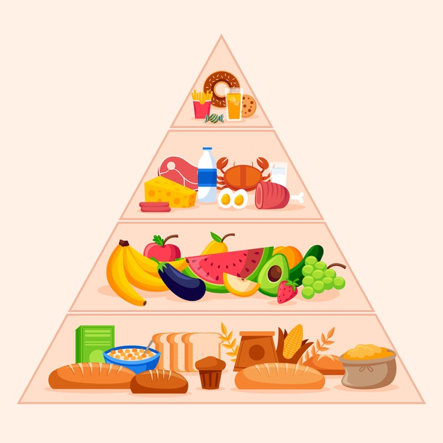
Cereals, bread, pasta
fat, oil, sugar, sweets
Meat, fish, milk, eggs
Fruit & vegetables
Food Pyramid

