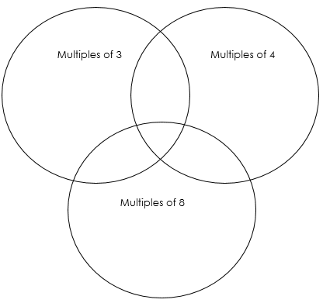
Answers:
88

80

72

48

64

56

8

32

40

16

96

24

44

28

20

4

36

33

30

9

15

27

21

18

12

6

3

Word problems:
- 9 x 3 = 27
- 24 ÷ 4 = 6
- 8 x 5 = 40
- 27 ÷ 3 = 9
- 6 x £8 = £48
- 36 ÷ 4 = 9

