(Answers)

Bronze  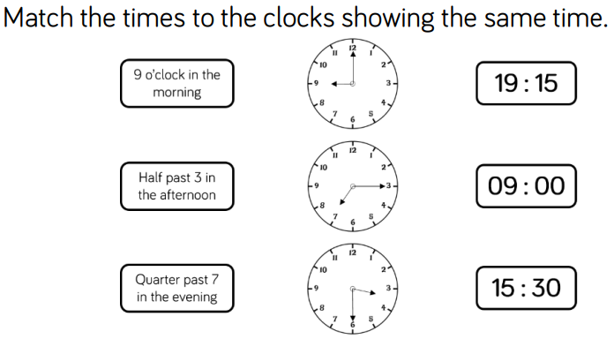 | Silver  - Quarter to two in the afternoon  - Twenty past eleven in the morning  - Ten to four in the afternoon  - 15:45  - 17:35  - 08:40
Gold  Eva could be correct. The clocks are both showing twenty past 8. However, the analogue clock does not show whether the time is a.m. or p.m., so this could be showing 8.20 a.m. or 8.20 p.m. | Greater Depth  1.17 pm

