Year 5 Newsletter

Welcome to the start of a new academic year! I am really looking forward to a successful first year at the school.

What are we fighting for?
This half term we will be exploring the question: What are we fighting for? Y5 were briefly introduced to the idea of studying World War 1 during transition week, producing some really interesting questions and outstanding WW1 silhouette art. This year marks the centenary, which we will explore, as well as what life was like during the war and why it began. We have lots of exciting things to look forward to linked to our topic.
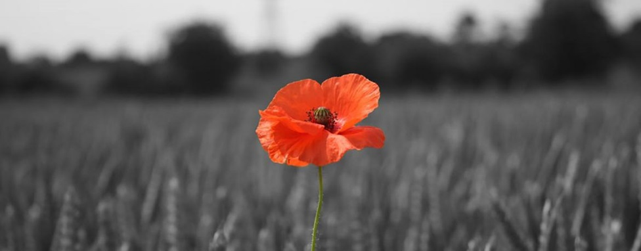

English
Linking with our theme, this half terms focus book will be ‘War Horse’ by Michael Morpurgo. We will be delving into this bestselling book by one of our country’s leading authors and exploring it in a number of ways. Over the half term, we aim to cover a range of writing genres including; diary entries, poems, advertisements, and persuasive speeches. During grammar lessons we will be focussing on punctuation, paragraphs, tenses and relative clauses. In addition to this, we will have daily handwriting and spelling lessons where we aim to develop children’s understanding and add to their prior knowledge.
Mathematics
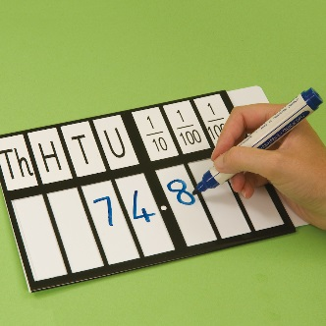
We will begin this term by applying our understanding of number and place value, before moving onto consolidating our understanding of measures, geometry and fractions, decimals and percentages. In addition to these daily morning sessions we are have mental arithmetic lessons for 15 minutes each afternoon to ensure fluency in each child’s number facts and times tables. It is vital that all children are secure in their knowledge of these number facts. We therefore strongly encourage children to continue to practise their times tables at home.

PE
This year, Year 5 will be receiving PE lessons on a Thursday. We are very lucky to have a PE coach at Birklands, who will be teaching the children a range of skills. In order to take part, children need to be wearing their PE kit, which includes a white t shirt, black shorts and trainers. Please ensure these are in school at the start of each week to enable your child to participate in sessions.

Homework
It is expected that children read at home at least three times each week. Reading is such an essential skill, particularly in Upper Key Stage 2. The more your child reads, the better their reading, comprehension, spelling and writing will become. Whenever your child reads at home, please sign their reading diary. These reading diaries need to be brought to school each day. Maths, English or topic homework is set each Thursday and due in on Tuesday. Homework will always link to the work in class that week, therefore, it is essential that your child brings their homework in on time so that they are prepared for their new learning.

It is vital that children attend school every day. Please ensure that your child is punctual to ensure they do not miss any learning.

If you have any questions please do not hesitate to come and see us or give us a phone call!

Thank you for your continued support,

Mr. Brightman

