Measuring Perimeter

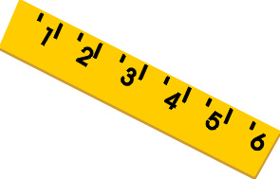

1. Measure the perimeter of 3 different types of chocolate bars. Don’t forget to write down which measurement you used! (mm, cm, inches)

|  |  |  |
| --- | --- | --- |
| Chocolate bar name: | Workings out: | Perimeter: |
| Estimate: |  |  |
| Estimate: |  |  |
| Estimate: |  |  |

1. Measure the perimeter of 2 books you have read recently.

|  |  |  |
| --- | --- | --- |
| Name of Book: | Workings Out: | Perimeter: |
| Estimate: |  |  |
| Estimate: |  |  |

1. Measure the perimeter of 3 items of your choice from your house. Can you find the perimeter of an item that isn’t a square or rectangle?

|  |  |  |
| --- | --- | --- |
| Item Name: | Workings Out: | Perimeter: |
| Estimate: |  |  |
| Estimate: |  |  |
| Estimate: |  |  |