Thursday 25.06.2020
Fluent in Five
- 7,000 – 597 =
- 752 + ___ = 2,000
- ___ x 10 = 34
- 0.2 + 12.9 =
- 12 x 6 =
Times Table Rockstars
Spend 10 minutes on TT Rockstars (ON SOUNDCHECK PLEASE!)
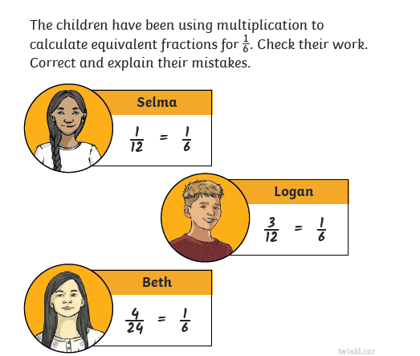
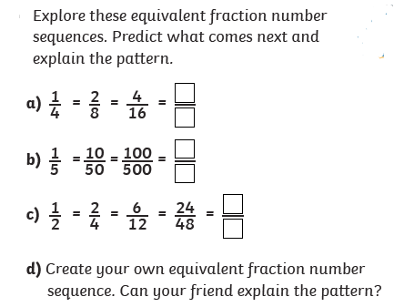
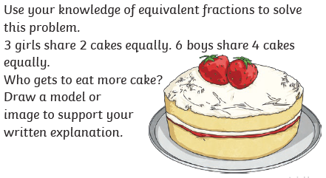
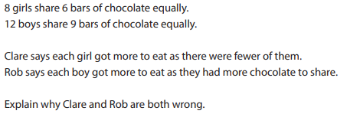
Maths Task – Equivalent Fractions
3)

4)

1)

2)

