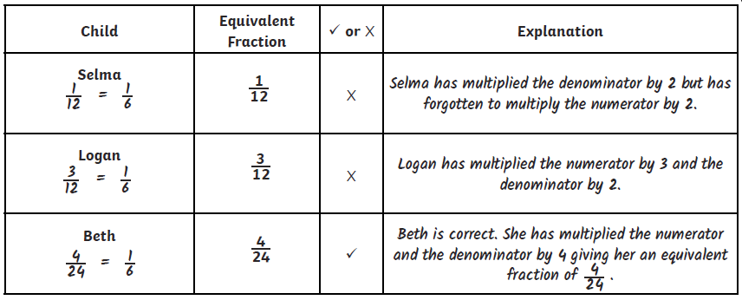**Thursday 25.06**

**1)**

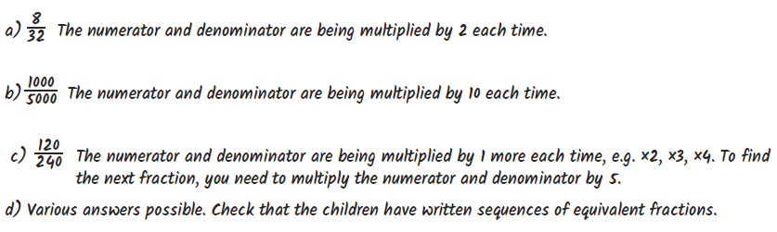

**2)**



**3)**

They are both wrong because they boys and girls would eat the same amount of chocolate. The girls would get 6/8 of a chocolate bar and the boys would get 9/12.

6/8 = ¾ and 9/12 = ¾.

**4)**