Monday 22.06.2020
Fluent in Five
- 106 + 1,906 =
- 489 – 196 =
- 100 x 32 =
- 12 x 4 =
- 0.6 + 4.4 =
Times Table Rockstars
Spend 10 minutes on TT Rockstars (ON SOUNDCHECK PLEASE!)
Maths Task – What is a fraction?
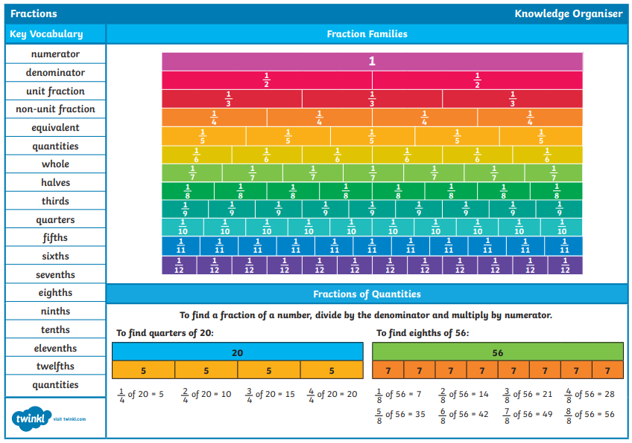
This week we are looking back at the learning we did on fractions earlier in the year. Have a look at the knowledge organiser below to remind yourself of the key learning on this topic.

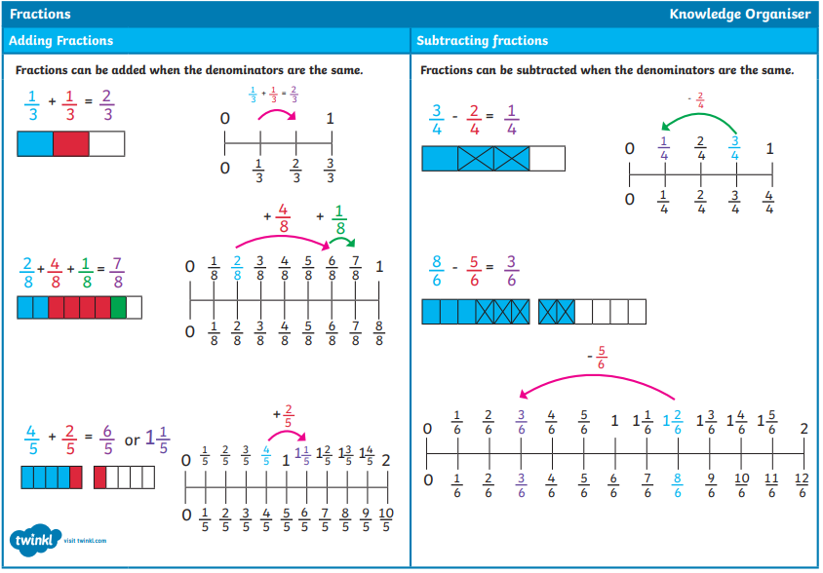

- Have a go at writing a definition to remind yourself what a fraction is.
- What is the name of the top number of a fraction?
- What is then name of the bottom number of a fraction?
- What is a unit fraction?
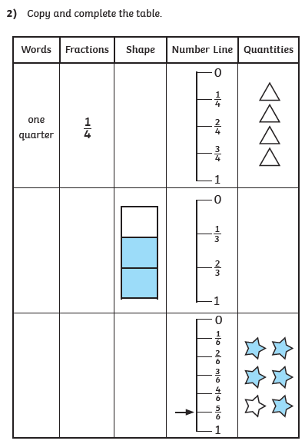
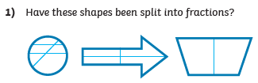
Explain why?

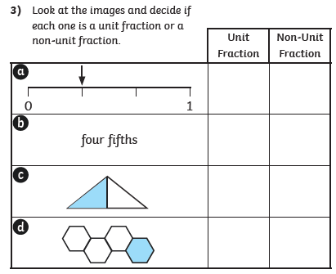

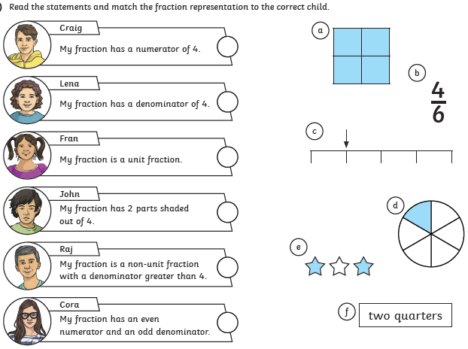
4)

