Monday 22.06
- A fraction is a part of a whole.
- Numerator
- Denominator
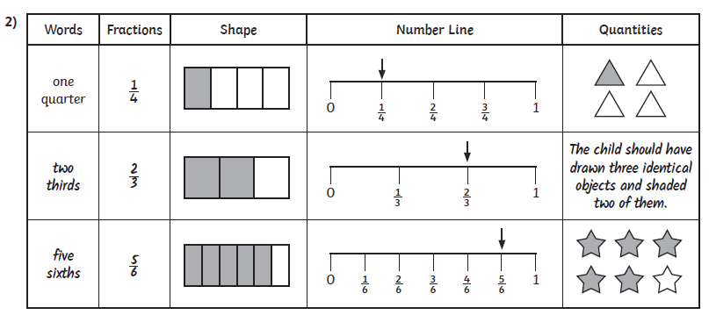
- A unit fraction has a numerator of 1
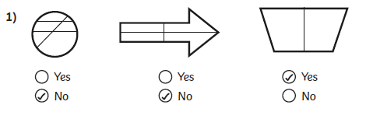

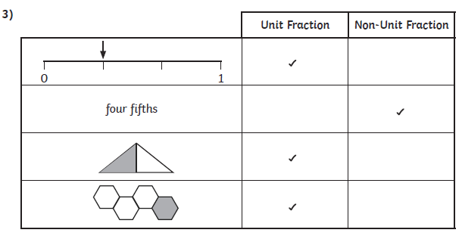
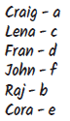
4)

