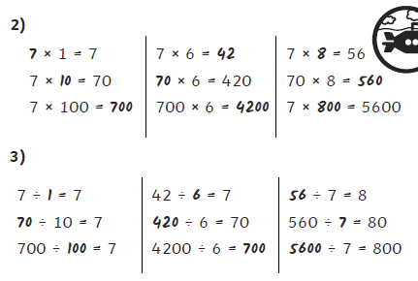
Thursday 21.05.2020
- 42 35
420 105
4200 140

4) Yes; £7 x 12 = £84, so he will have £4 remaining after buying the present.

