Tuesday 19.05.2020
Fluent in Five
- 1,008 – 854 =
- 2,997 + 107 =
- 9 x 26 =
- 540 = ___ x 9
- 2 x 12 x 9 =
Times Table Rockstars
Spend 10 minutes on TT Rockstars (ON SOUNDCHECK PLEASE!)
Maths Task
We are carrying on with our 9 time tables today, looking at the multiplication and division facts.
Challenge 1
Count in steps of 9 to draw a pathway through the maze, moving vertically, horizontally or diagonally.
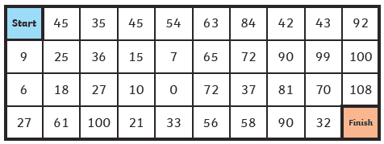
Challenge 3
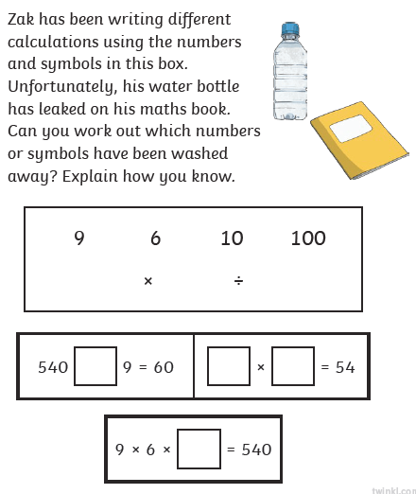
Challenge 2
