Wednesday 17.06.2020
Fluent in Five
- 699 ÷ 3 =
- 780 + ___ = 2,000
- 100 X 0.79 =
- $\frac{8}{12}$ - $\frac{2}{12}$ =
- Write 257 in Roman Numerals
Times Table Rockstars
Spend 10 minutes on TT Rockstars (ON SOUNDCHECK PLEASE!)
Maths Task – Counting Squares
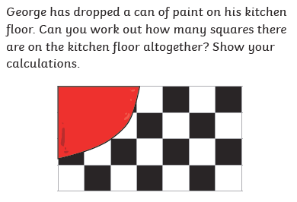
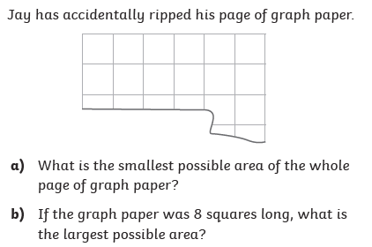
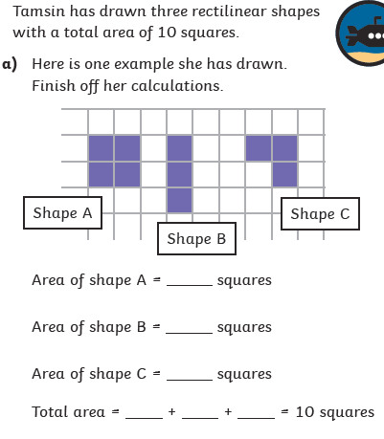
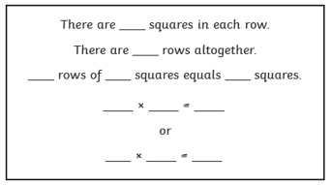
1)
2)
4)
1)

3)

