Thursday 14.05.2020
Fluent in Five
- $\frac{4}{5}$ of 55 =
- 25 ÷ 1 =
- 9 x 0 =
- 1,811 – 489 =
- 78 x 5 =
Times Table Rockstars
Spend 10 minutes on TT Rockstars (ON SOUNDCHECK PLEASE!)
Maths Task
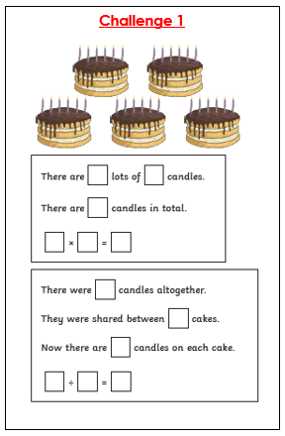
Today’s task will focus on multiplying and dividing by 6. See if you can write out your 6 times table from memory before having a go at the tasks.
