Friday 12.06.2020
Arithmetic
- 348 + 100 =  - 39 ÷ 8 =  - 4721 – 916 =  - 3.56 + 0.08 =  - 60 x 5 = | - 847 ÷ 7 =  - 653 x 4 =  - $\frac{5}{6}$ of 36 =  - 60 ÷ 12 =  - ___ x 9 = 63
Times Table Rockstars
Spend 10 minutes on TT Rockstars (ON SOUNDCHECK PLEASE!)
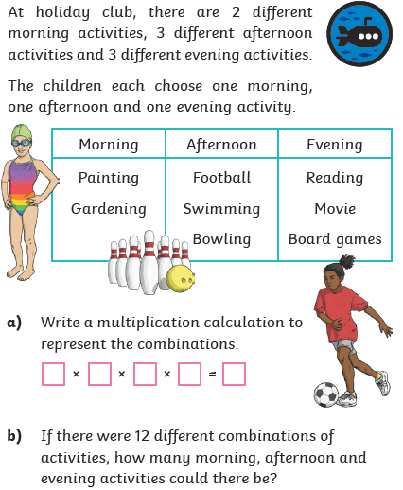
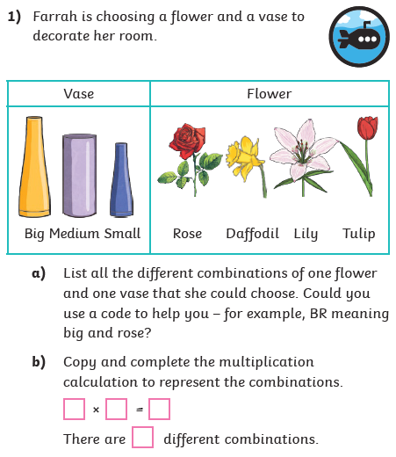
Maths Task – Correspondence Problems
2)

4)
3)

