Thursday 11.06.2020
Fluent in Five
- 24 ÷ 6 =
- 96 ÷ 3 =
- 109 = 53 + __
- 0.8 + ___ = 1
- ¼ of 88 =
Times Table Rockstars
Spend 10 minutes on TT Rockstars (ON SOUNDCHECK PLEASE!)
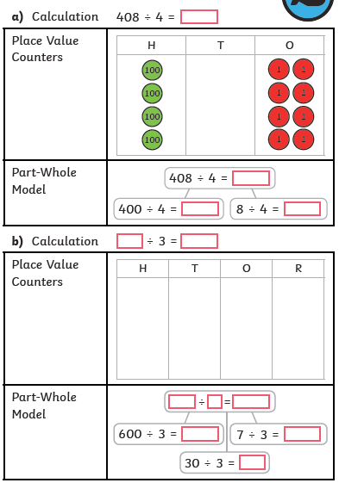
Maths Task – Dividing 3-digit numbers by 1-digit numbers
1)

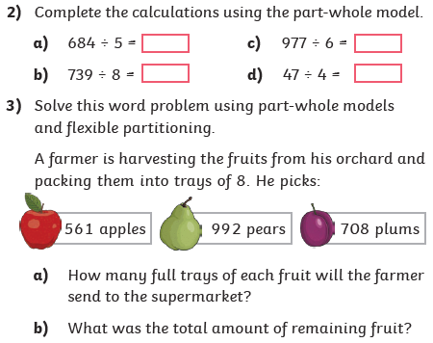

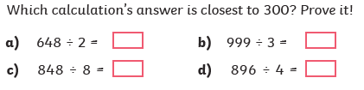
4)

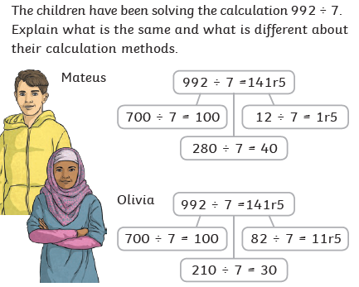
5)

