Wednesday 10.06.2020
Fluent in Five
- 10 x 4 x 3 =
- $\frac{4}{4}$ of 48 =
- CCCIX =
- ___ - 87 = 241
- 0.12 x 10 =
Times Table Rockstars
Spend 10 minutes on TT Rockstars (ON SOUNDCHECK PLEASE!)
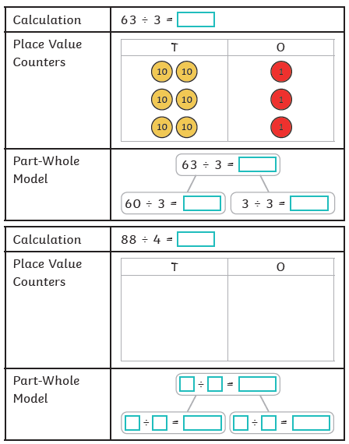
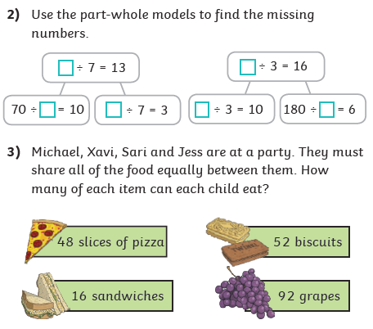
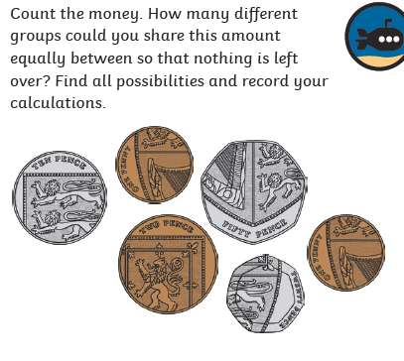
Maths Task – Dividing 2-digit numbers by 1-digit numbers
1)
4)

