Friday 05.06.2020
Arithmetic
- 715 – 30 =  - 759 + 300 =  - 96 ÷ 8 =  - 33 x 6 =  - 3 x 10 x 7 = | - $\frac{2}{9}$ + $\frac{4}{9}$ =  - $\frac{4}{7}$ of 28 =  - 459 ÷ 9 =  - 137 ÷ 10 =  - 4.7 x 10 =

Times Table Rockstars
Spend 10 minutes on TT Rockstars (ON SOUNDCHECK PLEASE!)
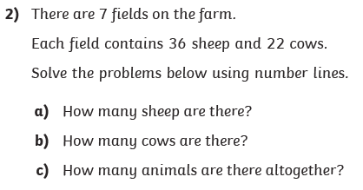
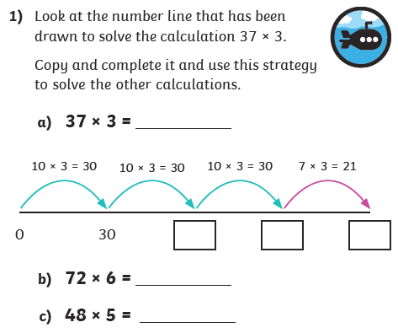
Maths Task - Written methods

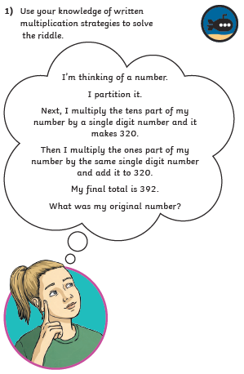
4)

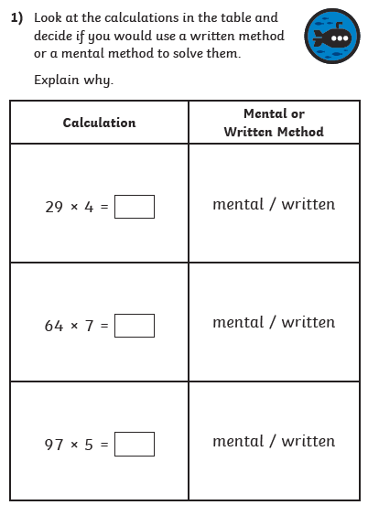
3)

