Thursday 04.06.2020
Fluent in Five
- 6,078 + 2,179 =
- 100 x 2.7 =
- 6 x 10 x 8 =
- $\frac{4}{9}$ of 81 =
- 147 ÷ 7 =
Times Table Rockstars
Spend 10 minutes on TT Rockstars (ON SOUNDCHECK PLEASE!)
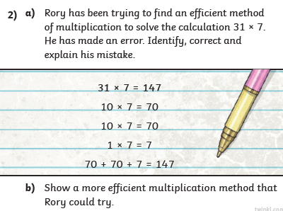
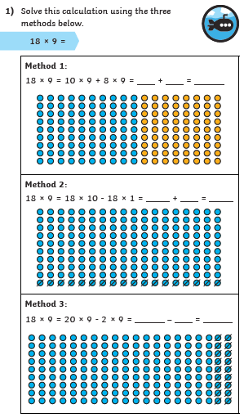
Maths Task - Efficient multiplication

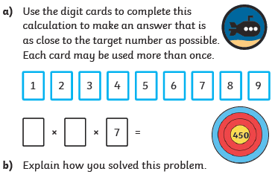
3)

