RE curriculum intent
At Birklands Primary School, we believe that developing:
- Independent learners
- Creative thinkers
- Socially confident and responsible citizens
- Cultural knowledge
will provide our pupils with the positive powers to make a difference in their lives and break the cycle of deprivation.

The impact of this is that through the teaching and learning of Religious Education we:
- Allow children to develop knowledge, understanding and mutual respect for the diverse society they are part of teach our children how to show respect and tolerance of cultural and religious beliefs.
- Encourage children to reflect on their own beliefs and values.
- Aim to engage, inspire, challenge and encourage children to ask and respond to intriguing, challenging questions.
- Develop and nurture curiosity and inquisitiveness by posing each lesson as a question.
- Allow children to be independent learners, creative thinkers and develop religious knowledge and understanding through the use through Bloom’s Taxonomy.
- Aim to challenge pupils through questioning, feedback, generating learning objectives and success criteria.
- Believe this can be achieved through the exploration of different religious beliefs, values and traditions that are followed in our multi-cultural/ multi-faith society.
- Want children to recognise how Religious Education shapes lives and behaviours, and
- Develop pupil’s ability to make reasoned and informed judgements about religion.
- Enhance their spiritual, moral, social and cultural development.
- Encourage children to explore non-religious world beliefs.
- Promote understanding that enables our children to combat prejudice, preparing them for adult life, employment and life-long learning

At Birklands Primary School, we have made the decision to use the agreed RE Syllabus for Nottinghamshire. We believe that by following this, we can ensure children are provided with a multitude of insights and knowledge to enable them to live as responsible citizens in our society within the ever-changing world in which we live.
Each year group will follow the three areas of learning taken from the agreed Syllabus:
- Know about and understand a range of religions and worldviews.
- Express ideas and insights about the nature, significance and impact of religions and world views
- Gain and deploy the skills needed to engage seriously with religions and world views
By doing this, we aim to broaden the children’s understanding and develop their world-wide awareness.
As a school we have agreed that R.E coverage will be taught as a block unit of work. We have made this decision, as we feel that by teaching in blocks, we allow children to think deeper and explore more complex questions. During each block we interweave the RE focus into other curriculum areas, such as Art, Design Technology and English. This enables our pupils to produce varied final products.
All teaching and learning is planned and delivered in accordance with Rosenshine’s principles of instruction. The knowledge should therefore be memorable and transferrable.

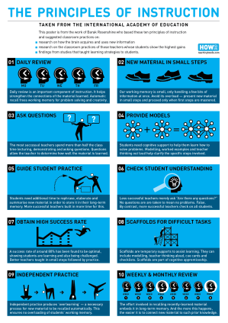
During the planning process, staff are encouraged to consider prior learning, new learning, Assessment for Learning, key vocabulary and key questions. This enables teachers to deliver high-quality lessons that build on prior learning and develop deeper thinking. By considering prior learning, we can ensure that we create a spiral curriculum which engages and challenges all learners.

Each lesson begins with an activity that encourages children to revisit and recap on prior learning. Through this deliberate practice, children are encouraged to draw upon past experiences and make links across the R.E syllabus.

Through each unit of work, we use a range of quality texts that inspire children to explore their own beliefs and those of others. By adopting the ‘Book Journal’ approach in English, children are immersed in Religion through their curriculum. This approach ensures children to have ample opportunity to consider questions and follow their own lines of enquiry by developing their thinking in a philosophical manner.

At Birklands Primary School, we believe it is important to learn about other religions and why people choose, or choose not to follow a religion. Through their Religious Education learning, children are able to make links between their own lives and those of others in their community and the wider world. Through Religious Education our children are developing an understanding of other people’s cultures and ways of life, which they are able to communicate to the wider community.

Teachers will assess the understanding of children within R.E lessons through the use of a range of assessment for learning strategies and through pre and post-unit quizzes. This will be used to inform future planning and address any misconceptions.

